Work Sheet For Calendar in MS Office Excel Program

Firstly in that lecture we will create a calendar for October month together. This calendar will take shape thanks to your creativity. Firstly we examine the example calendar which is prepared by LÖSEV.After this lecture you will learn to regulate the size of cells, color of cells and to add them ClipArt, WordArt, pictures. You should follow the steps of study to create effective one. Good Luck
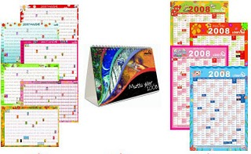

The steps of preparation of calendar:

- Open MS Office Excel and give a name to your sheet such as October Calendar, October 2010.
- Use you windows calendar. You can find it right bottom of desktop. It facilitates you to place the day of October on the cells.
- You should drop a space row on the top because you will give a name to your calendar.
- Then write the name of day (Monday, Tuesday…)

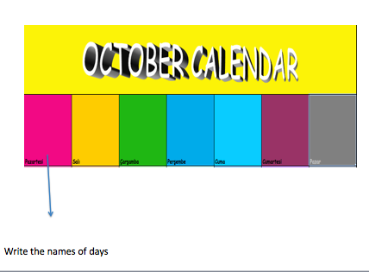

5) Write the day number on cells. There is a clue in that point. After you write 2 numbers of days for a row you can pull it from the right – bottom side. Through it you can fill with the day number on the column for one row.

- Also you will notice that you should stretch the size of cells because you cannot insert ClipArt, WordArt or picture while they are in that size. Select all of the cells (ctrl + A) and make bigger them from the left- topside with dragging the arrows.

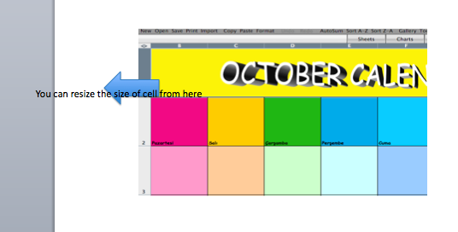
7) Now your creativity is starting. You give color the cells of day. For instance red is for Monday, green is for Wednesday. Whatever you want. And then you can find the compatible colors also for the column like hue of color.

8)The most enjoyable part is coming. We will put ClipArt, WordArt, and picture on cells. How can we do this? Please look at the menu bar. Do you realize any similarity with MS Office Word Program?

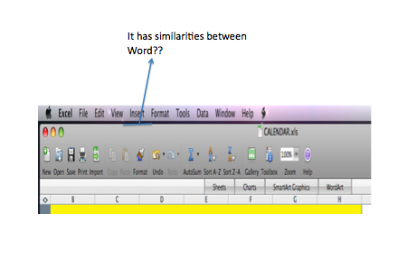

You can insert photo or ClipArt from insert button from menu bar like Word Program and then arrange their size also.

9) Select the special date for you on October and add related photos, ClipArt to their cells. Maybe you can write some notes not to forget (Don’t Forget! Mum’s birthday.)

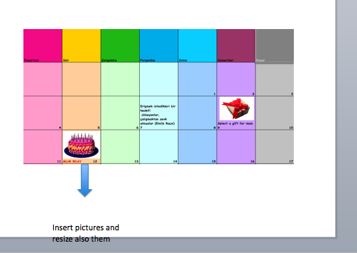

10) The last step is your calendar is finding a header such as (Mert’s Calendar, Calendar of October). You can prepare it with using WordArt so that it can be glamorous. And also while doing it, you can use ClipArt for October. Find them from Internet with searching for October.

11) Finally you prepare your personal calendar. You can print and hang it to your room’s wall

