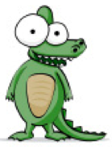

CREATING TABLE WORKSHEET (TABLO OLUŞTURMA)

! Please don't forget to put a header in your document.
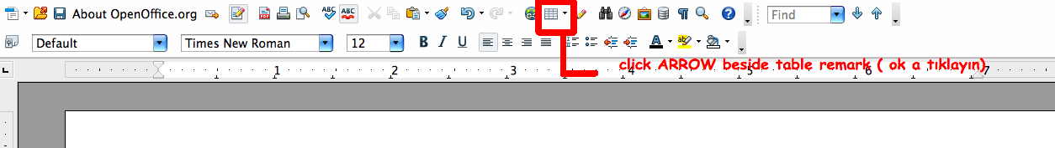
Activity1:
We will create a table easily. Firstly, click the arrow like upper picture. After you click it, there will be schema to select number of boxes. Hold your hand on the table schema and select rows (yatay) and columns (dikey). 10 rows ( yatay) and 3 columns (dikey) should be on your table.

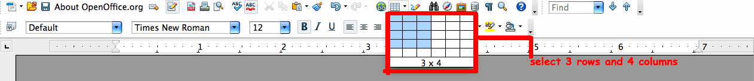
You should create a table like below. After create it, lets start animals name. You can select
your favorite animals.

Animal name | Number of legs | Living Place
Dog | 4 | Land
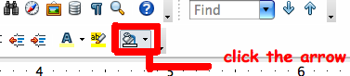
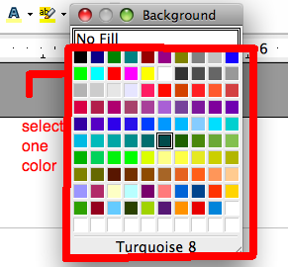
Activity 2:
After you write at least 8 animal, you should make color to your table. Select the first row (yatay) and click paint icon like upper, select one color you want. Please apply the same for other rows. Your table is well done. Thank you for your effort to animals
!!Don't forget to save your document.


